Work Instructions for Starting Procedure for MAC

GUIDE LINES FOR SHIFT ENGINEERS/ G SHIFT ENGINEERS-ELECTRICAL

Objective : Effective functioning of shift /G shift

Scope : All shift Engineers/ G shift Engineers

Ref : Nil

- Aspect: Nil
- Impact: Nil
- Hazards: Nil
- Behavioural hazards: Non adherence to SOP, safety procedures, PPE

Responsibility: Electrical Engineers

- Shift handing over and taking over should take place between both shift engineers. Shift handing over engineer should explain to his reliever personally all the problems faced in the shift along with history of his previous shift and the precaution and actions to be taken. Without explaining personally, the engineer should not leave the factory premises. Shift handing over Engineer should write in the shift report that he has personally explained all the problems faced in the shift, any activities/ breakdowns to be carried over and attended in relievers shift. Same should be signed by the shift Engineer. Similarly reliever should write that he has understood the same and sign.
- At the start of the shift , engineer shall communicate his name to BF 1 &2 control rooms, BF3 shift electrical engineer and to GEL control room.
- Mobiles should not be used at working area.

- At the start of the shift, engineer in charge shall provide PEP talk to his workmen working under him. Job allotted to the workmen / contractor shall be in writing through a job allocation slip duly filled in. All the hazards associated with the activity and its control measures shall be briefed to workmen / contractor. Engineer in charge shall also ensure right PPE’s/ certified tools and tackles are used by his workmen / contractor.

- Shift engineers must brief their electrician about major problems like repetitive tripping or motor burning on particular drive or any problems which has previous link, so that in their absence he can attend the problem as he will be aware of the gravity of the problem/situation.

- Never replace only moving or fixed or only one or two contacts of any power contactors. Always replace a full set of contacts (six fixed and three moving). Any deviation of the above norm will have to be authorised by Dept. Head.

- Whenever a motor is changed on any drive (including man cooler) it’s current and abnormality like heating or sound should be observed for at least three days, once every shift. Any problem on that drive, even if it trips should be informed to HOD, Section Head or any other senior person.
- Any change in load drawn from GEL/ NPP due to stopping or starting of furnace or due to transfer of load on DG during DG trails need to be intimated to GEL/ NPP at the earliest opportunity.

- Whenever there is a problem with any equipment in service related to production, the engineer must check with production people and find out if there is any wind reduction because of the electrical breakdown. The same has to be written in the log book without fail.
Wind reduced from ______to______.
Level of wind reduction ______N/m3.

- Panel doors of electrical feeders are to be kept closed. In case they are open for some reason, please ensure that they are closed after the work and door interlock is taken in line.

- Whenever any motor is replaced or power circuit in any starter is disturbed (for relay changing/contactor changing/cable reterminations etc.), please ensure that the direction of the drive is proper. If required consult either a mechanical or a process engineer. In case of conveyor having hold back, directions needs to be checked after decoupling the motor. In any case Electrician shall note down the connection details before dismantling, and connect them back as per the noted marking. Engineer In charge shall cross check this activity of noting down and verifying the connection after completion of job. Direction shall be confirmed firmly by checking motor direction preferably when RPM comes to a halt. At full RPM one cannot make our or judge the correct direction of rotation. Incase of drives with forward/ reverse operation and having limit switch for cut off then direction trial has to be taken by inching operation and checking whether motor supply is getting cut off by physically operating particular direction limit switch by hand. If after operating limit switch if motor supply is not getting cut off means direction is reversed and needs correction. After correction of direction again trial has to be taken by inching operation and by operating limit switch.

- Working of P.A. system in the, CAT dg house and electrical workshop engineers’ room should be ensured at the beginning of the shift and the status should be logged in the log book. Also proper functioning of Walkie-talkie shall be check at the beginning of the shift. Any malfunction in walkie-talkie should be reported to Instrumentation Dept.

- ABB relay, capacitor current measurement checklist has to be filled by engineers every month as per the names on the checklist.

- Whenever signing any report or independent checklist that is “event” which cannot be traced for date or is very difficult for tracing, must be signed with 'date'. As a habit you must always sign with date.

- Shift engineers must ensure that all electrical MCC doors are kept closed and are locked with padlock and all the door limit switches for lighting automation are working satisfactorily and status should be logged in the log book every shift.

- While signing the measurement sheet of any contractor please ensure things mentioned below:.
i..Area in which job is carried out along with cost centre
ii Date of carrying out the job.
iii. Date of certifying the job

- Shift engineer checklists are to be filled every shift in SAP without fail.
All are required to go through manuals that are kept in the electrical workshop.

- Shift engineer shall attend pending jobs given in the shift. He shall brief the status of the pending jobs to his reliever.

- During shutdown of the furnace, graphite on crane should be cleaned by using vacuum cleaner only and should not be blown down. If it is not possible, it should be blown down after taking clearance from people working below. (Probably during lunch break).

- Whenever there is an overload tripping of any drive, whether the conveyor/pump/crane, it must be informed to the shift mechanical engineer and should be resetted only after mechanical clearance. While attending breakdowns related to slip ring motor rotor sound and rotor current to be checked. Rotor current needs to be checked at motor resistance box.
- Whenever the job is given to mechanical like machining, where dimension are involved the same should be communicated in writing with a note in the log book.

- Whenever blowers are being started, the shift engineer has to remain in the blower’s house, until the blowers are taken in line.

- Shift engineer must take a round for checking BF-2 battery / CAT DG panel battery/TG Battery charger within two hours from starting of shift without fail.

- Shift change should be done by taking prior permission

- Whenever there is breakdown in a working furnace and whosever receives the message must attend the breakdown without waiting for shift engineer.

- Whenever the motor is to be removed by cutting its foundation bolt with gas cutter, you must see that fan is removed before using gas cutter if it happens to be a plastic one.

- Motor should be lifted by using special rods only, which are kept at tool room.

- Generals shift tools from tool room will be issued strictly by taking signature of the user in “tools issue register”. Tools which are handed over to shift engineer after normal working hours will be kept in the shift cupboard and same will be handed over to tool room incharge next day personally by 'A' shift engineer.

- PCC is having 2 no’s neutral switch one for 3.5MVA transformer incomer & one for 5.5 MVA transformer incomer.
- Under normal condition PCC section A and section B is charged through their respective incomer with bus coupler OFF .During this condition both 5.5MVA incomer and 3.5MVA incomer neutral switch should be in ON position. In case of problem with 3.5MVA transformer both sections of PCC is powered from 5.5MVA transformer with bus-coupler ON condition and 3.5MVA transformer neutral switch should be in OFF position Prior to changing over PCC section B on 5.5MVA transformer PCI and DISA load should be put off as this load cannot be catered through 5.5MVA transformer due to busduct temperature rise.
- In case PCC section A needs to be charged from 3.5MVA transformer than one of the furnace needs to go for shutdown. PCI and DISA has to be put off. Load not to exceed 2434 amps on 3.5MVA transformeras its FLC is 2434 amps . When both sections of PCC is powered from 3.5MVA transformer with bus coupler ON condition then 3.5MVA transformer neutral switch should be ON and 5.5MVA transformer neutral switch should be in OFF position.

- Issuing and normalisation of shutdown permit in case of 3.3KV/11KV/33KV is to be done strictly with the supervision of electrical engineer in-charge.

- Cables are to be dressed on cable tray by using cable ties only and not by using armoured wire.

- Whenever motor is burnt and replaced, before switching ON new motor, starter feeder has to be inspected thoroughly like power contactor checking, overload relay setting check, relay testing, 03 phase availability at motor end etc.

- On Planned S/D day, during Furnace start-up, respective area Engineer along with the Electrician will be at site with Walkie Talkie for Furnace start-up coordination with Mechanical & Production. One engineer will remain in PLC room to co-ordinate with all the site Engineers through Walkie-Talkie. No Engineer will leave the site unless & until all the equipment in his area are started & furnace is given wind.

- While attending breakdown near newly commissioned site or commissioning in progress site please ensure that there is enough illumination at site. Due care should be taken to check the site condition i.e. all chequers plates are in place, all gratings are in place, uneven level of ground etc.

- During power failure at PID-1 due to failure of GEL/ NPP power supply, BF 3 outgoing breaker at PID-1 will trip on undervoltage( The provision of breaker tripping on undervoltage is given to avoid supplying power to BF3 without / permission of PID-1 shift electrical engineer), CAT DG set kept in auto will start automatically. After CAT DG auto starting, it is to be ensured that acoustic enclosure exhaust fans (2nos. for each DG) to be started manually. Further auto Blower no:1 of BF1 & BF2, Cooling tower pumps of BF1& BF2, Return Water Pumps of BF1,2 will start in Auto. After starting second DG before synchronising please ensure following
a) Put OFF jetty outgoing 11 KV breaker & inform GEL , MCD, raw material and dispatch shift In charge accordingly.
b) Match speed/frequency of both the DG’s.
c) Match Voltage of both the Dg’s.
Third DG can be synchronised following step no b & c.
After starting all the three DG’s, all 6 nos. of acoustic enclosure exhaust fans should be started, and should be stopped after DG’s stopping.

- After sharing equal load on all three DG’s and if there is a requirement of PIP DG power to BF3 on account of total black out in Amona Complex switch on BF 3 outgoing breaker at PID-1 and give clearance to BF3 for drawing emergency power required for their cooling water circuit. If the power failure is only at PIP and BF3 do not need DG power from PIP then BF1 and BF2 start-up clearance may be given depending on CAT DG loads. Before starting blowers give clearance to start overhead make up pump 2 or 3 for PCI and one PCI compressor for lance cooling so that sufficient time is available to remove the lances from furnace. After lances are removed from both the furnaces PCI compressor and overhead make up pump for compressor to be stopped after taking clearance from SS.Consult shift superintendent to know which furnace blowers are to be started first. Start 1 furnace all blowers and take in line. Stop Blower 1 and close the new line motorised damper. Ensure wind is not increased. Similarly start second furnace all the blowers and take in line. Stop Blower 1 and close the new line motorised damper. Take Intac DG support if required. Now coordinate with both control rooms and increase wind volume in steps so that load on CAT DG’s does not exceed 1.2MW each and load on Intac DG does not exceed 300KW.

- Shift Engineer shall ensure to take load trial of CAT DG & Intac DG every Monday in first shift. Also auto start trial of Cat DG shall be taken by putting OFF BUS PT sensing 4P MCB at 11KV PIP outgoing panel. Also UPS incoming 230V supply should be put off while taking CAT DG trial to check healthiness of the UPS.
- Shift engineer shall ensure to carry out daily lighting checklist in B shift and create notification for the deviations and also mention the deviations in the lighting complain register.

- Every day ‘A’ shift engineer shall review shift consumables like anabond, rust lick, insulation tape etc & shall replenish the stock in shift cupboard.

- For motor replacement, spare motor from Cat DG house will be shifted to site only after the approvals from electrical in charge and above level authority. While giving approvals of spare motor , one has to ensure that, motor is ready in all respect such as test bed vibration , temperature, motor bearing and overhauling / rewinding history. While replacing motor with a spare one ensure RPM of spare motor is same as that of motor which needs to be replaced.

- Motor connections( star delta ) done by the electrician will be verified for its correctness of winding connection by Engineer In charge before switching ON the drive from trial.

- In case if any drive is instantly tripping on overload, check 3phase supply, all 3 power fuses, all 3 phase current. Check for looseness of power circuit.

- While attending breakdowns & taking trials there should be proper coordination between Electrical, Mechanical & production Engineer. Before operating any equipment in remote/field mode, the person operating the equipment should ensure clear & proper communication & operate the equipment only after acknowledging the instruction.
One such example of effective communication is illustrated below.
Sender: Please put Off the Drive.
Receiver receives the message & acknowledges
Receiver: O.K
Receiver puts off the drive & replies back.
Receiver: Drive is put Off.
Sender receives the message
Sender: O.K.

- Whenever blower motor DE or NDE temperature shows increasing trends (alarm), check for grease accumulation in grease cup, check for BTD connection tightness at motor JB, sub JB. Also cross check BTD resistance and corresponding temperature. If DE/ NDE bearing temperature reaches 90deg, immediately take standby blower in line and stop the blower as it can lead to bearing seizing.

- Whenever any belt trips on zero speed, if at all zero speed needs to be bypassedsame should be done in zero speed unit at site.

- If cooling tower VFD thermal state is increasing, VFD internal blower and 3 no’s external cooling fans on panel to be checked for working.

47.If contacted for BF1 & 2 ‘RWP SUMP ALARM’, shift Engineer should immediately go at site and coordinate with Mechanical and Production to discharge water from sump of Return water pumps.

48. Before entering gas prone area such as Ventury pump & Ventury Drive (GCS area), Hot blast stoves, thickener area(slag granulation panel room, Pcm recirculation panel , GCS panel room,
4T slag grab crane and 4T iron ore Grab crane ) Dust catcher , Top charging power pack, Hearth Area, Control room Enginner to be informed and min two persons should enter the area with 2 nos CO monitors.

49. Unbalance motor's shall be connected through RCCB and flexible cable from JB to motor shall have additional flexible GI mesh protection for protection against insulation damage.

50. All structures to be earthed by laying dedicated earth strip upto earthpit.

51. No power Circuit to be kept remain charged with faulty RCCB . In no case RCCB can be bypassed.

52.ZSS sensing bolt or its probe lenght to be adjusted in such a way that it is within the circumference of the gear and does not come in the gear meshing area so that even if the sensing bolt bracket bends due to any reason , it should not get entangled in the gear .

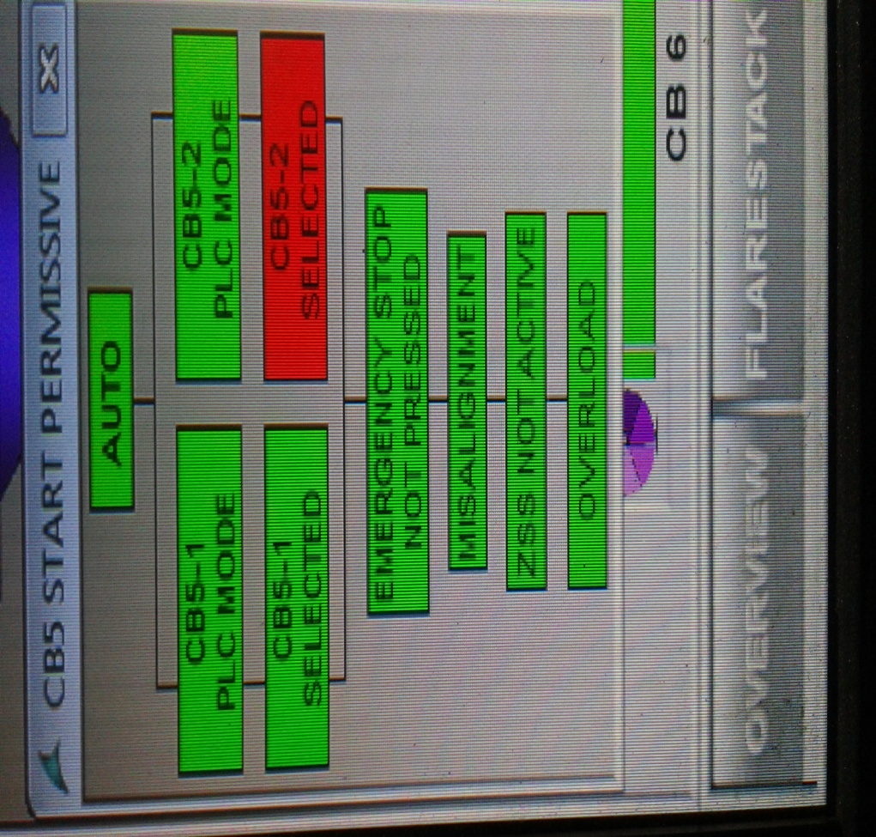

Amendement Record
Date | Manual Section Ref. & Para | Brief details of Revision | New Rev.

Prepared By:  Senior Elect. Engineer | Reviewed & Issued By:  Management Representative | Approved By:  Head – Electrical & Instrumentation PID I
Signature | Signature: | Signature:
Review Date: 04.03.2023 | Review Date: 04.03.2023 | Review Date: 04.03.2023

